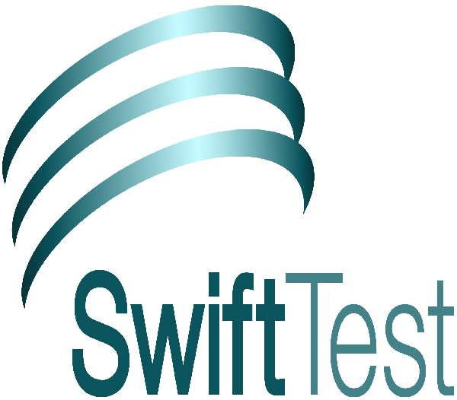
support@swifttest.com

5000 Appliance Network Connections

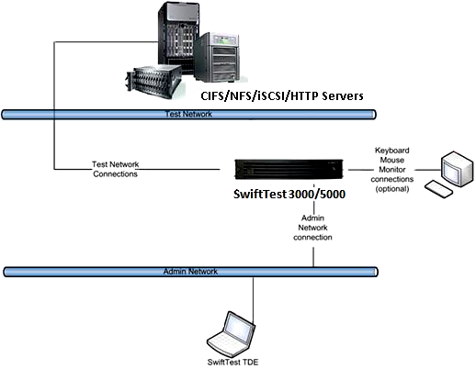
SwiftTest 5000
The SwiftTest 5000 Appliance 10Gbps physical test ports conform to the 10GBASE-LR/SR standard. The SFP+ transceiver uses an 850nm laser that requires a Multi-Mode Fiber cable with an SC connector. Use of an incompatible SFP+ transceiver will cause an error message containing the text “Generic Failure: Status Code ...” to be generated by the Appliance.

